You can form a neural network by stacking together a lot of little sigmoids.

Notation = [] refer to layers, and () refer to ith training example

a[2] is the final output used interchangeably with yhat.

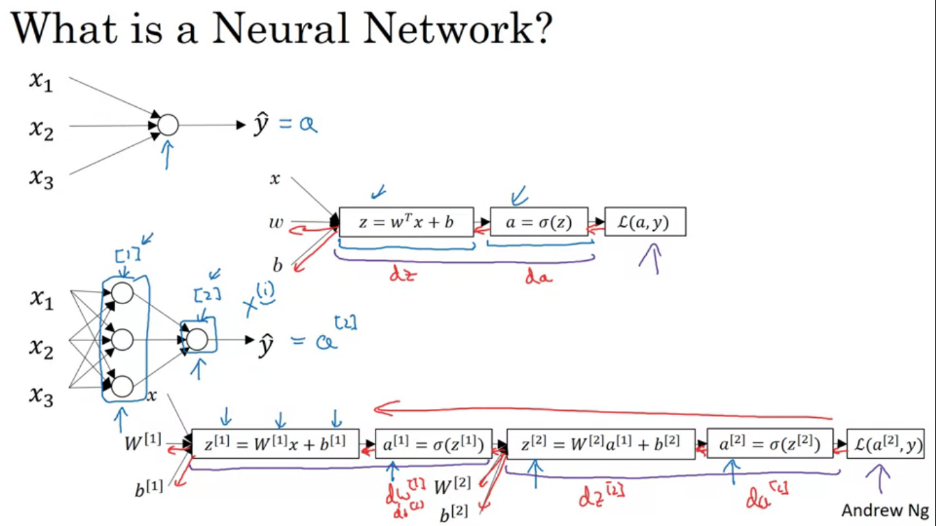

x1,x2,x3 are called the input layer of neural network

Single node layer is called the output layer and is responsible for generating output yhat.

In a neural network trained with supervised learning the training set contains values of inputs x as well as target output y

So the term hidden layer refers to the fact that in the training set, the true values for these nodes in the middle are not observed. You see the inputs and the outputs

Input layer(X / a[0]) passes on the value X to the hidden layer ,hidden layer(a[1]) will in turn generate some set of activations .

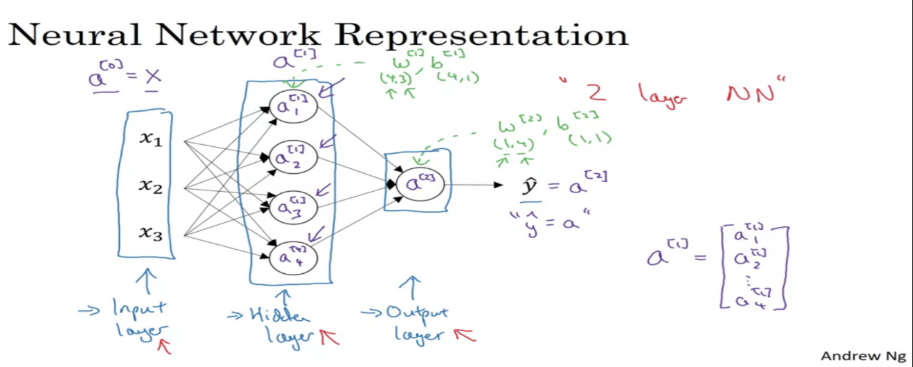

a[1] is a 4D vector (4X1) because we have 4 hidden units in the hidden layer

output layer generates a[2] which is just a real number

when we count the layers in the neural network we do not count the input layer

hidden layers and output layers have some parameters associated with them. Hidden layers have parameters W[1] and b[1], W will be 4X3 matrix and b will 4X1 vector. Output layers also have parameters W[2] and b[2] , with dimensions as 1X4 and 1X1

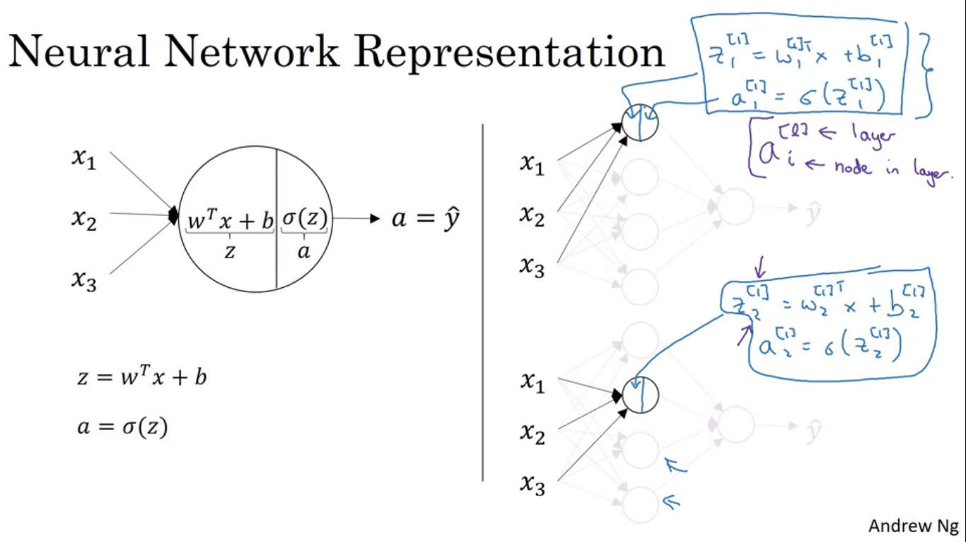

simple neural network working – it is like logistic regression but repeated a lot number of times.

Let’s start by looking at the first node of the hidden layer. Similar to logistic regression, this node in the hidden layer does two steps of computation -

Z[1] = W[1](t)X[1] + b[1]

A[1] = sigmoid(Z[1])

For better visualisation see the image.

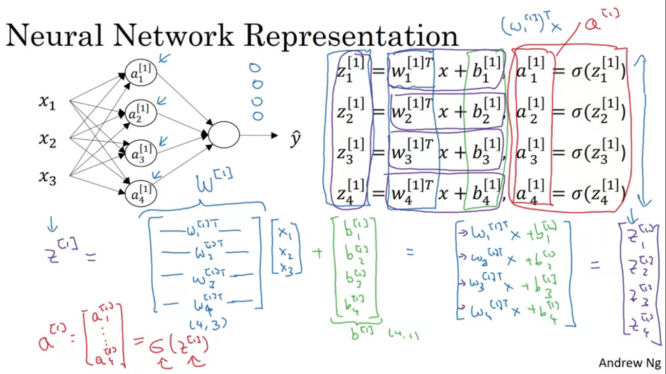

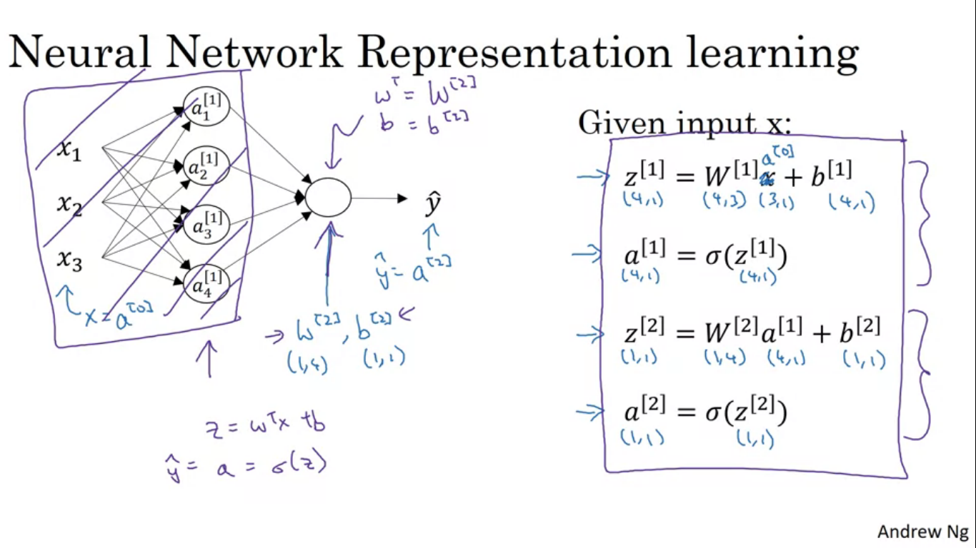

Doing the calculation for every node using a for loop seems inefficient. So we take these four equations and vectorize. To vectorize we stack the individual W layer in one matrix, making the number of rows as 4 and since W initially was 3 the size of matrix after vectorizing comes out to be 4X3.

When vectorizing one of the rule of thumb is that while we have different nodes in the layer we stack them vertically.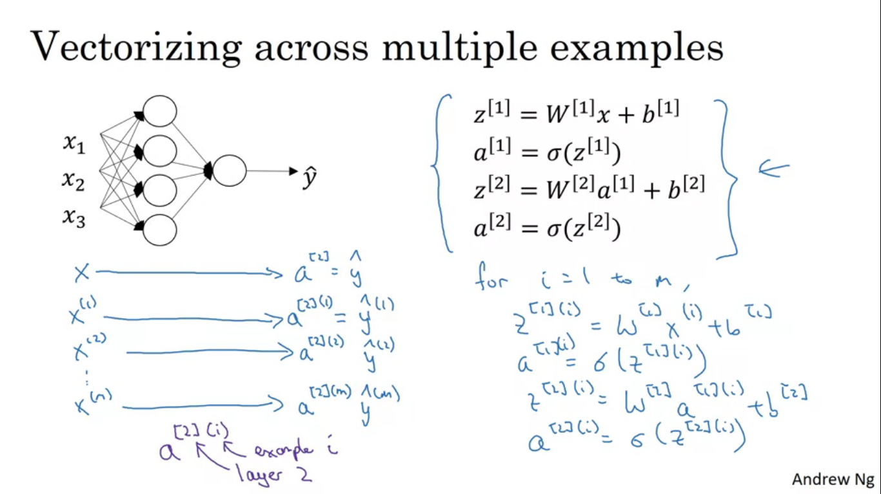

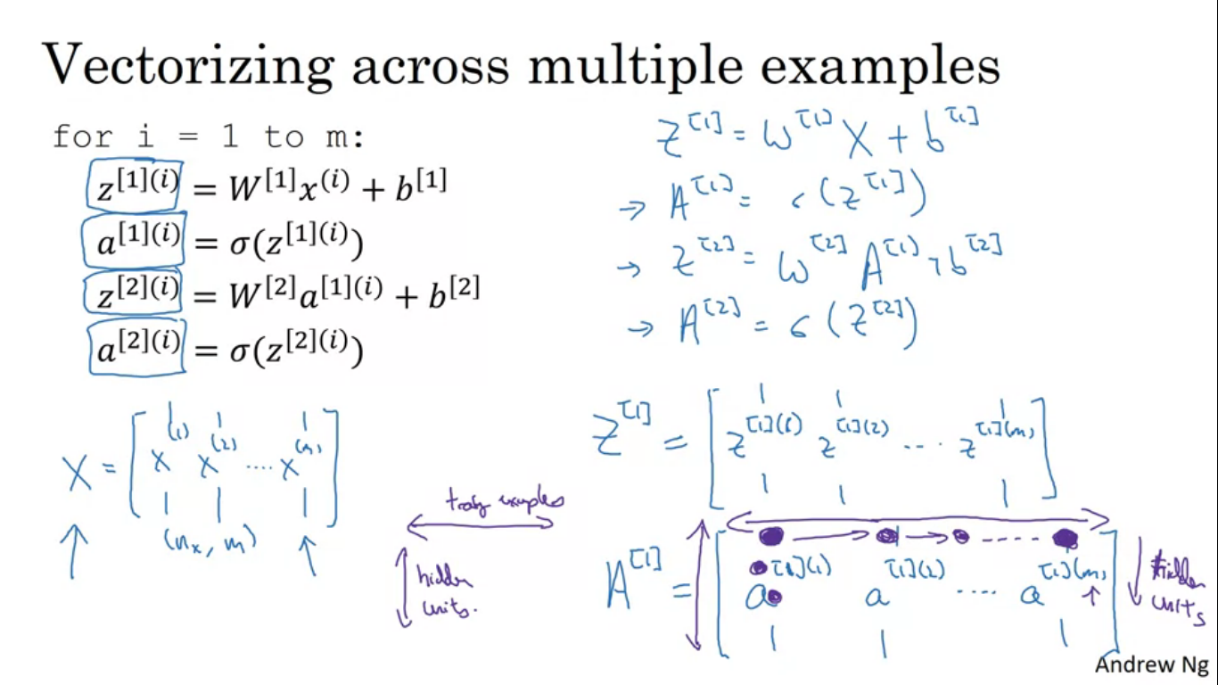

If you have m training examples you need to repeat the four equations as mentioned m times, so lets vectorize it too.

Move vertically

In the A[1] matrix, the top one corresponds to first activation hidden unit on first training example and second value down corresponds to second activation hidden unit in the first training example.

Move horizontally

First hidden unit first training example -> first hidden unit second training example-> and so on.

X me bhi

**Horizontally – different training examples**

**Vertically - different training features**

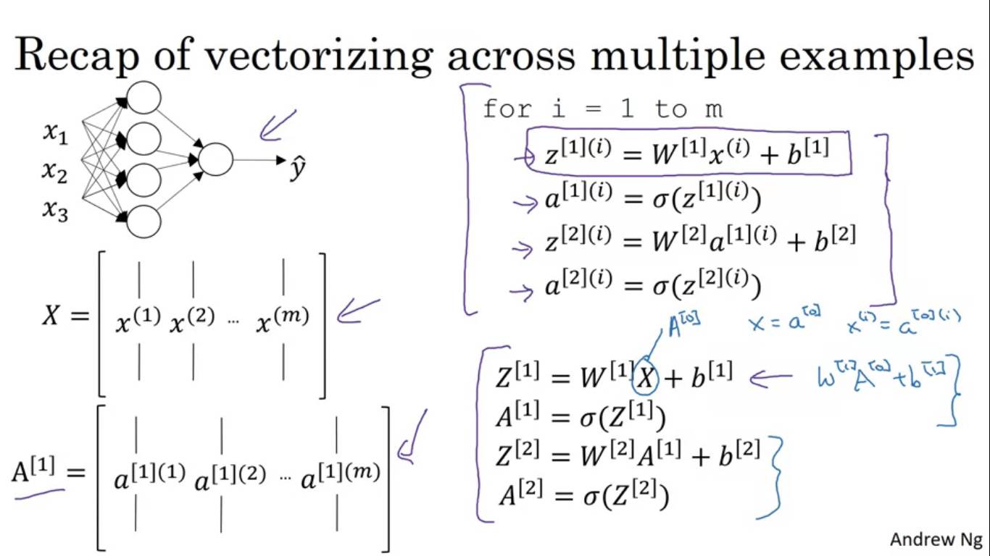

**Different activation functions**

Sigmoid is an activation function and sometimes some other functions might perform better.

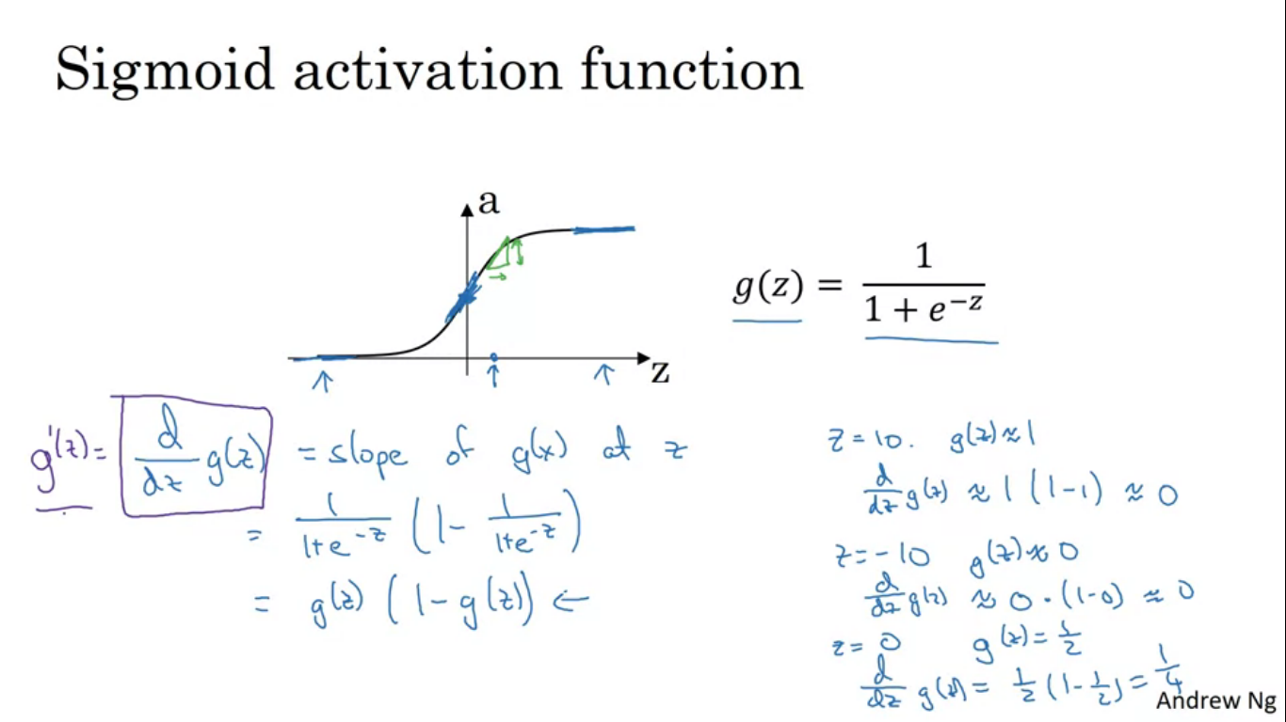

Activation function that always works better than sigmoid is the tanh function or the hyperbolic tangent function. Tanh goes between +1 and -1

Tanh = (e^z – e^-z)/ (e^z +e^-z)

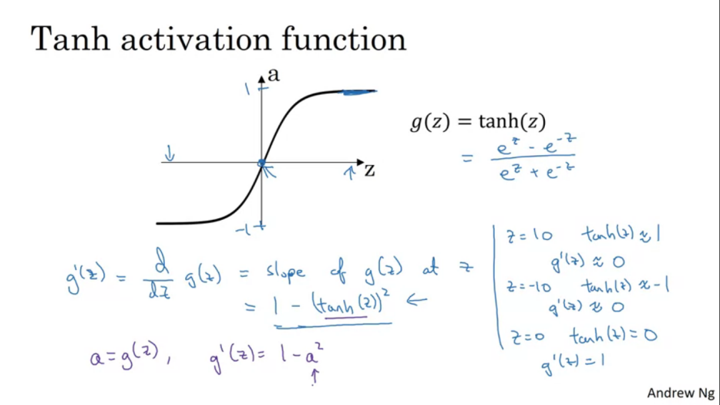

Tanh always works better than sigmoid because the values are between +1 and -1 , the mean of the activation that come out of your hidden layer are closer to having a zero mean .so when you are learning the algorithm you might center the data and your data has 0 mean using a tanh instead of sigmoid function , kind of has the effect of centering the data so that mean is closer to zero than say 0.5. we see this about in optimization course.

Tanh is better than sigmoid everywhere other than the output layer since in output we want the answer between 0 and 1 and not between +1 and-1

Activation functions can be different for the different layers.

Downsides of sigmoid and tanh function

If Z is either very large or small then the gradient/derivative/slope of the function becomes very small, close to 0, slowing down gradient descent.

Another very popular activation function is called rectified linear unit(ReLu)

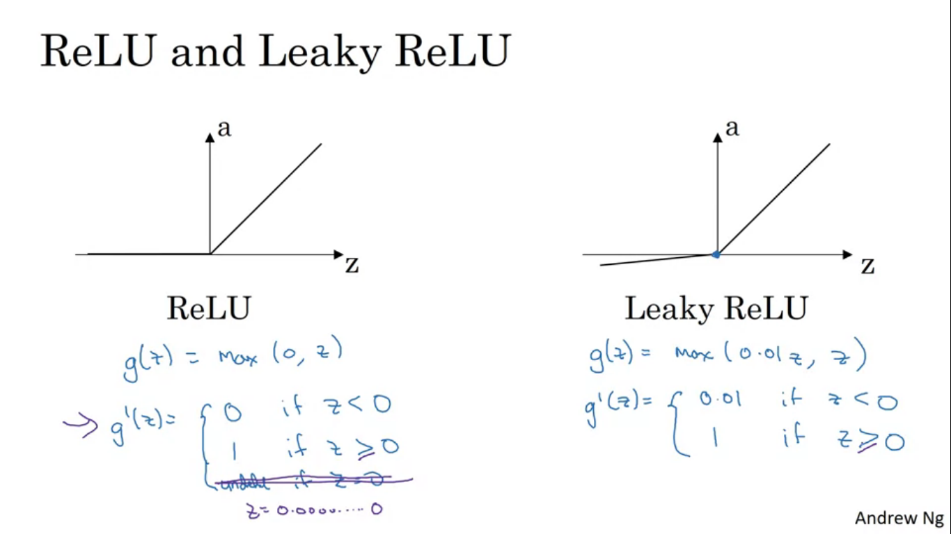

ReLu = a = max(0,Z)

So the derivative is 1 as long as Z is positive and 0 when Z is negative.technically, the derivative when Z is exactly zero is not well defined.

Rules of thumb for choosing the activation functions

* If output is either 0 or 1 then sigmoid is the best choice for the activation function at the output layer.
* For all other layers Relu is the default choice of the activation function.

Leaky ReLu – instead of lope being zero when Z is negative, it just takes a slight slope.

ReLu learns faster than the tanh and sigmoid because less effects of slopes of function going to zero, which slows down learning, hence it trains quickly.

**Why does a neural network need a non linear activation function?**

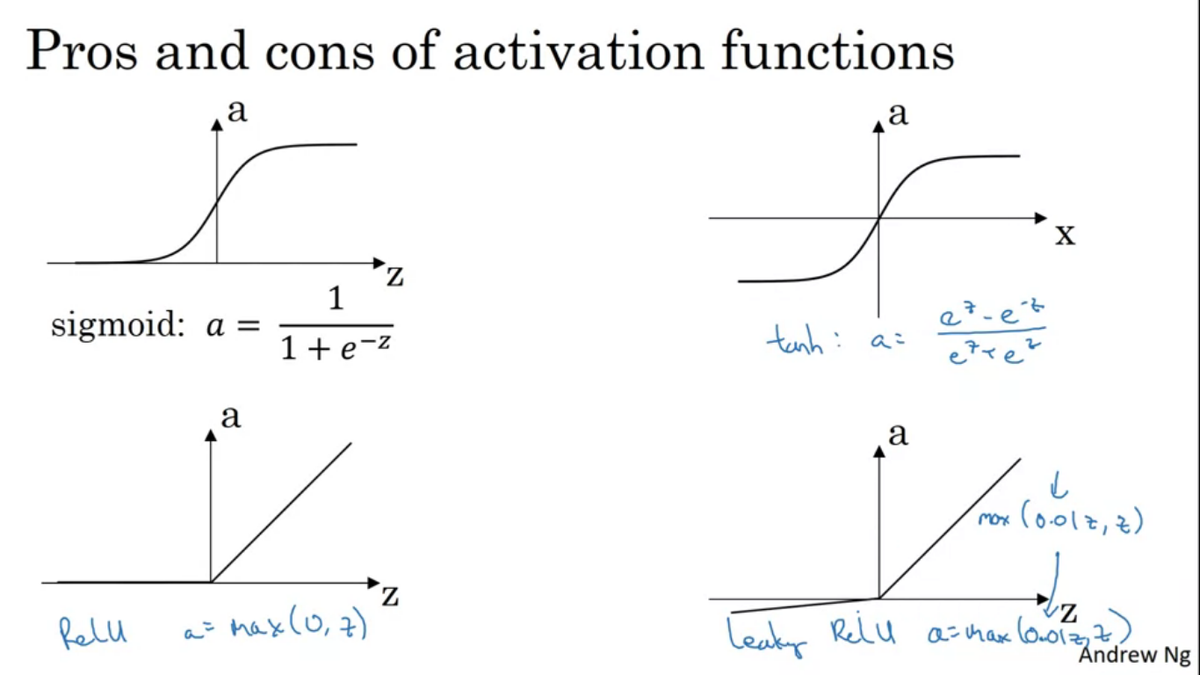

Had it been linear then our model would have been computing linear functions for the input features. So even if you had many layers all your neural network is doing is computing the linear activation function.

Unless you thrown in non linearity in there you aren’t computing interesting functions even if you go deeper in the model.

Doing machine learning on the regression problem is the only place where you might be using linear functions.

When you implement back propagation you need to compute the slope of the activation function.

**Back propagation / Gradient Descent Working on a neural network**

For binary classification the loss function to be used can be the one we used for logistic regression. To train the parameters of the algorithm we need to perform gradient descent.

When training a neural network, it is important to initialise all the parameters randomly rather than all zeros.

Keepdims = true is for preventing the output of the funny rank 1 arrays.

**Forward propagation:**

**Z[1] = W[1]X + b[1]**

**A[1] = g[1](Z[1])**

**Z[2] = W[2]A[1] + b[2]**

**A[2] = g[2](Z[2]) = sigmoid(Z[2])**

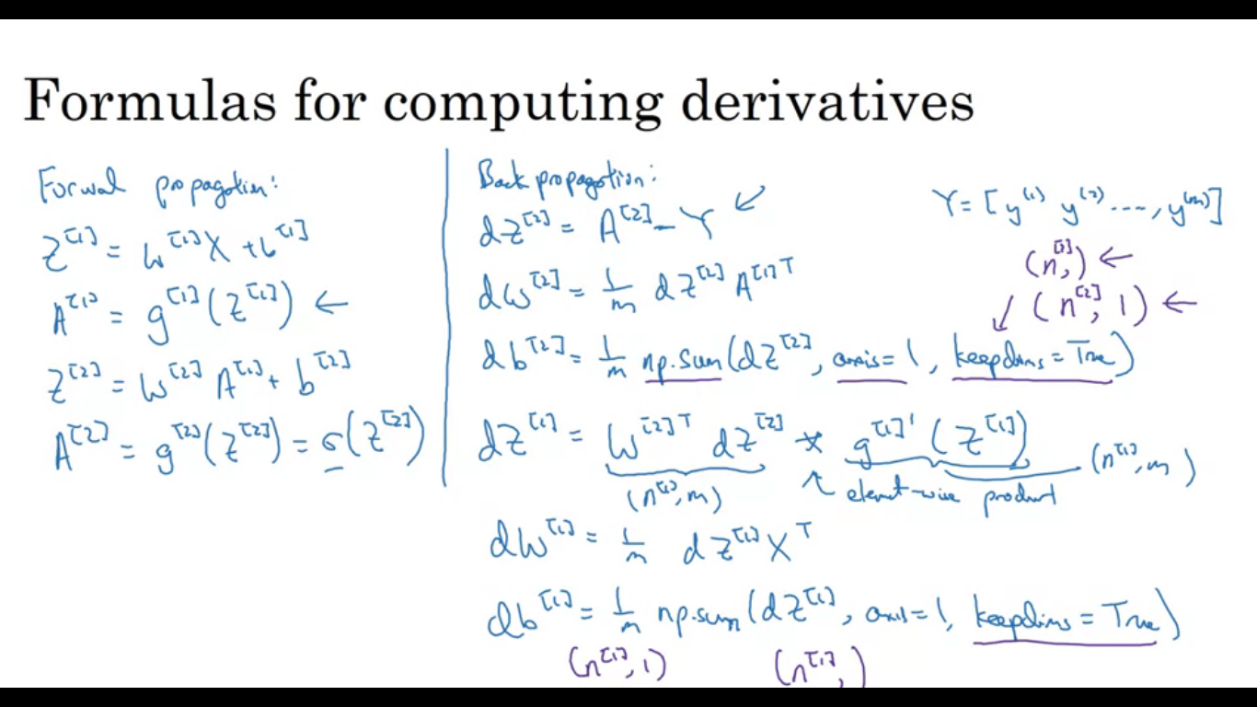

**Backward propagation:**

**dZ[2] = A[2] – Y**

**dW[2] = (1/m)dZ[2]A[1](T)**

**db[2] = (1/m)np.sum(dz[2],axis=1,keepdims=True)**

**so far what we have done here is very similar to logistic regression.**

**dZ[1] = W[2]dZ[2] * g[1]’(Z[1])**

**‘*’Is element wise product.**

**dW[1] = (1/m)dZ[1]X(T)**

**db[1] = (1/m) np.sum(dZ[1],axis=1,keepdims=True)**

Intuition using the computation graph as to how those equations were derived

Matrix W[2] is (n[2],n[1]) dimensional, Z[2] and dZ[2] will be (n[2],1 dimensional)

**Back Propagation intuition**

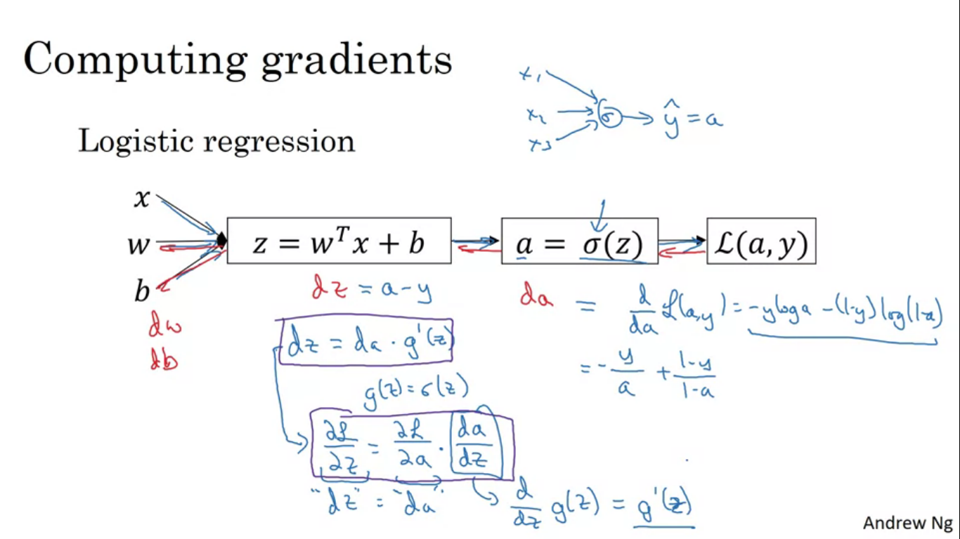

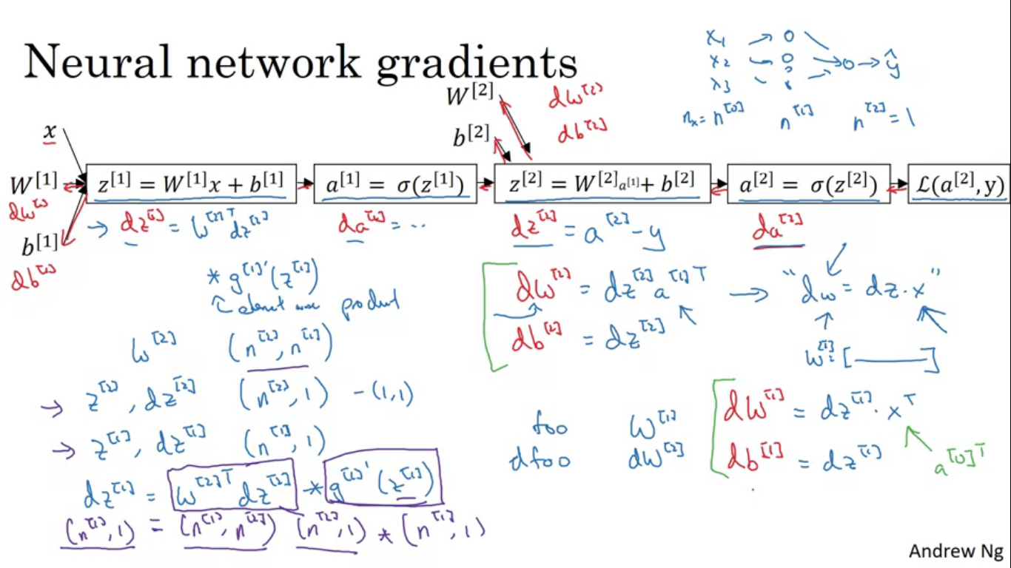

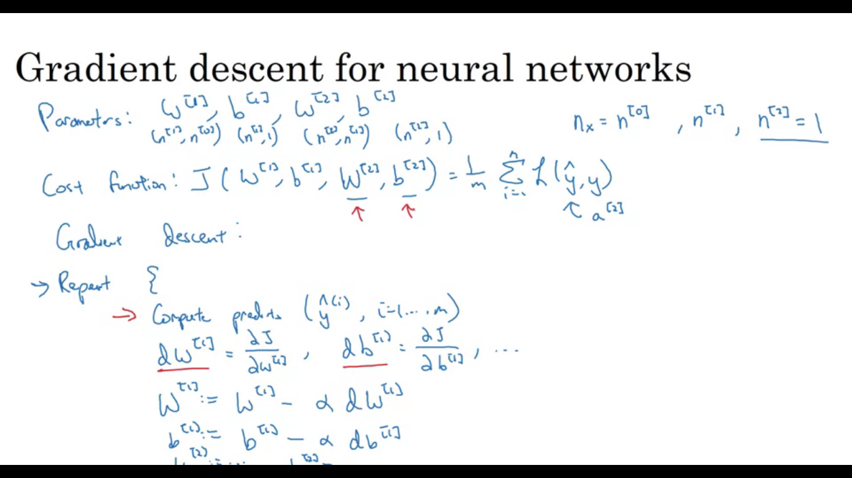

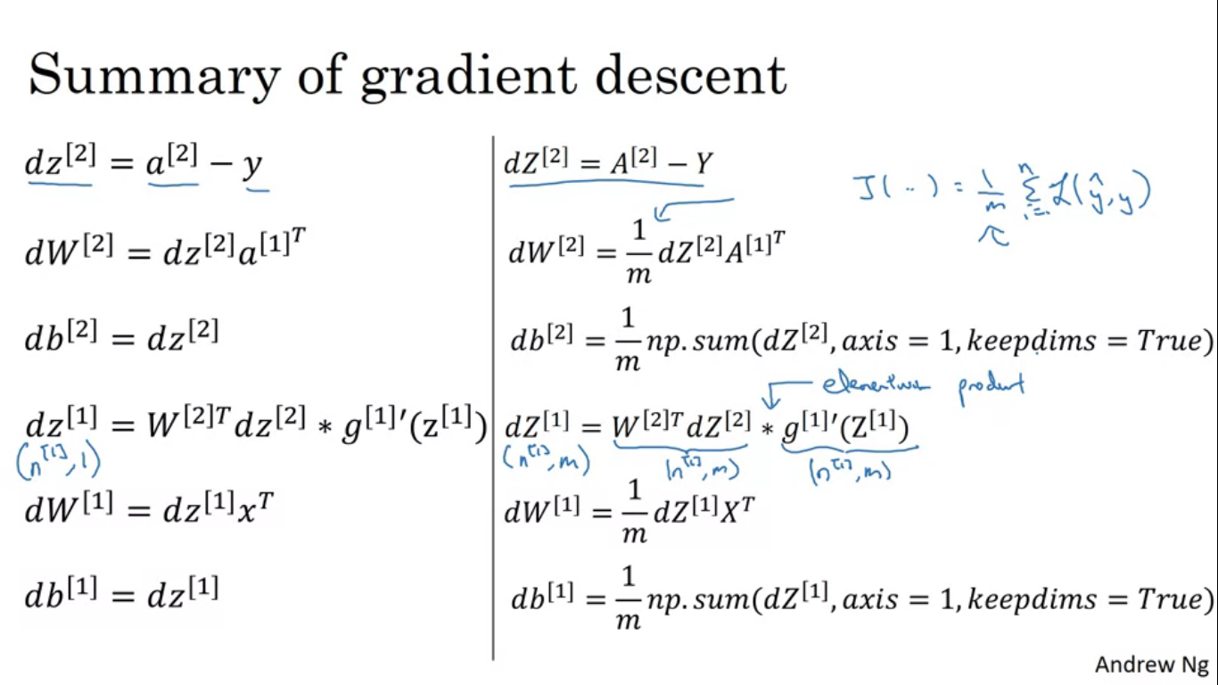

**Why do we need to initialise the weights randomly?**

For logistic regression it was okay to initialise the weights to 0 , but for neural network the zero initialisation to zero won’t work .

The hidden units will initialise the same way and would be completely identical. Both hidden units have the same influence on the output unit, then after 1 iteration the units are still symmetric. So no matter how long you train the neural network, both hidden units compute exactly the same function. Defeating the purpose of having more than 1 hidden unit.

We want different hidden units to compute different functions for the neural network to learn.

solution to this is to initialise the parameters randomly.

As long as W is initialised randomly, b can be initialised to 0

We tend to initialise the random to very small values hence *0.01, as if you are using sigmoid or tanh function , if the weights are too large when you compute the activation values you are more likely to end on the flat parts of tanh or sigmoid where the slope of the gradient is very small and slows down the training process.

